Outputs:

1. Output of pgm1:

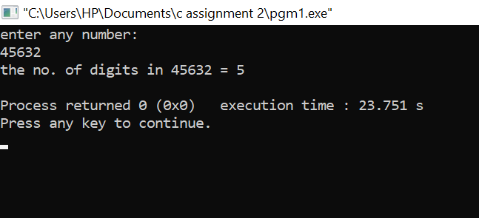

1. Output of pgm2:

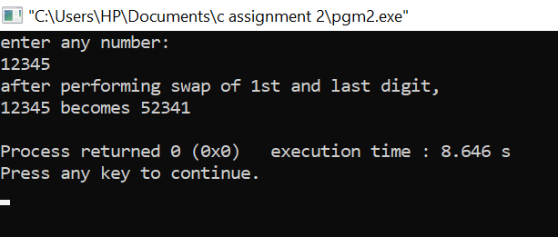

1. Output of pgm3:

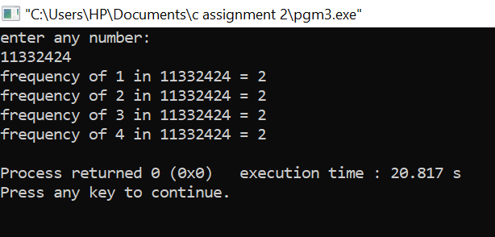

1. Output of pgm4:

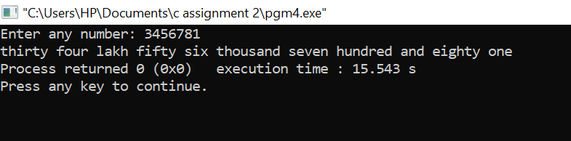

1. Output of pgm5:

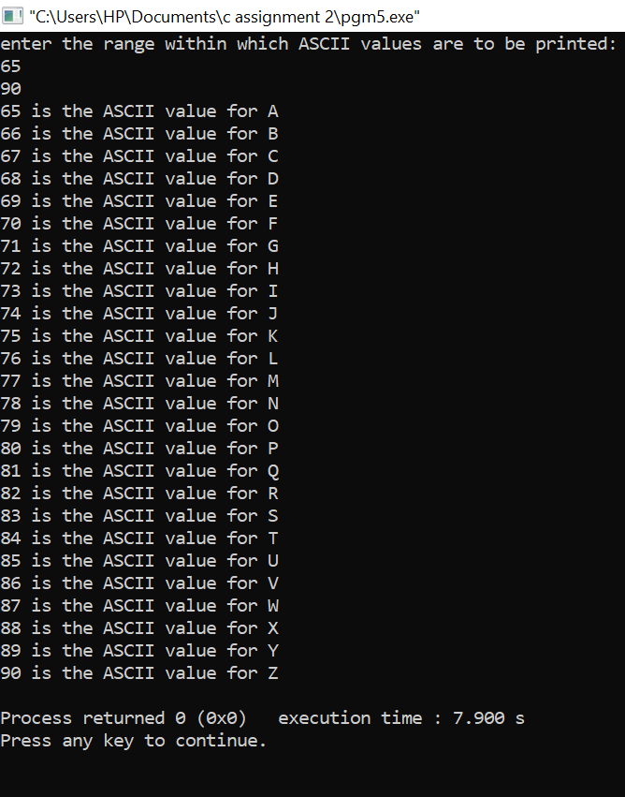

1. Output of pgm6:

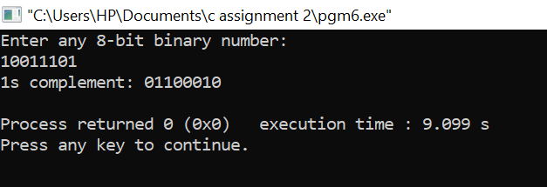

1. Output of pgm7:

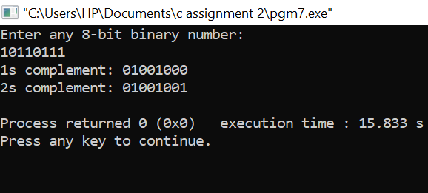

Thank you!!!